Consider this is the stack.

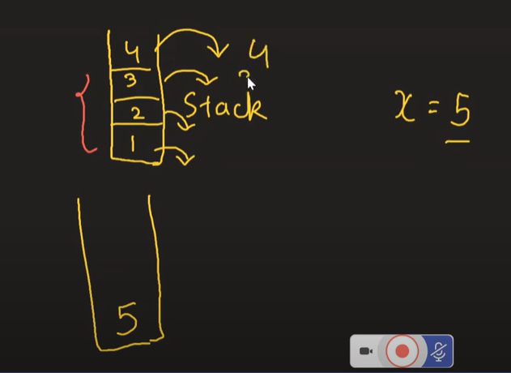

See we need to insert 5 in the stack at the bottom of the stack. So first pop all the other element and then insert 5 and then insert elements that have been popped again into stack in same order.